**IMPORTANT DATA**

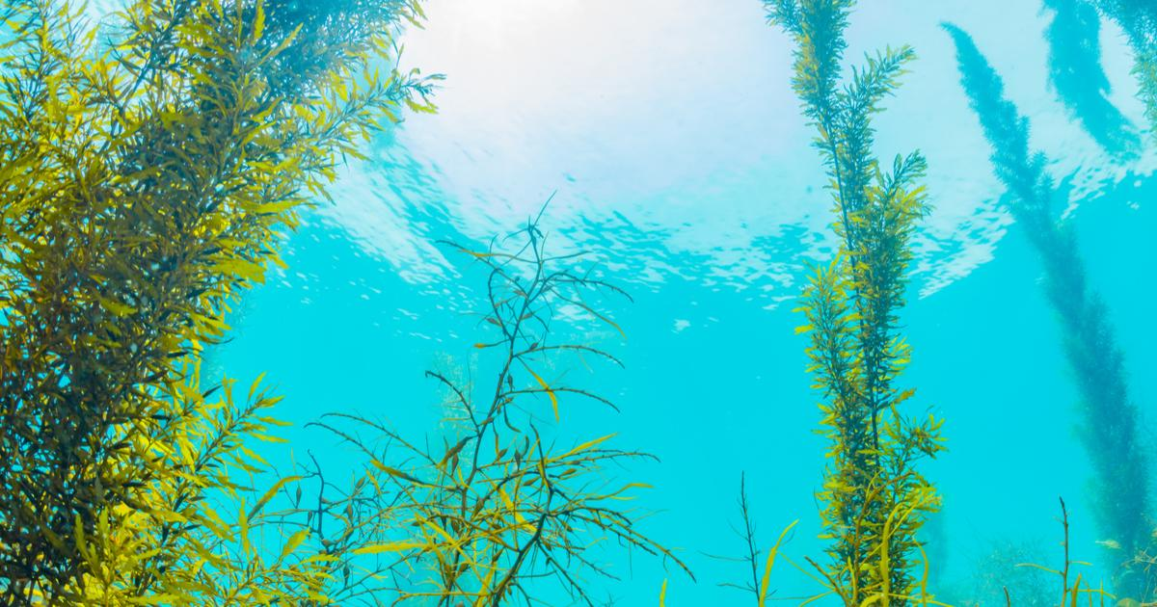

[This Photo](https://pursuit.unimelb.edu.au/articles/can-seaweed-fight-climate-change) by Unknown Author is licensed under [CC BY-ND](https://creativecommons.org/licenses/by-nd/3.0/)

* **Sea surface temperature (SST)**
* **Salinity**; more broadly, turbidity.
* **Light penetration**; specifically photosynthetically available radiation (PAR).
* **Micronutrient concentration**; specifically total oxidised nitrogen (TOxN). More broadly, nitrates and nitrites.
* **Dissolved oxygen (DO) concentration**; In correlation with SST, salinity, atmospheric pressure, water depth and biological activity.
* **Chlorophyll concentration** (which are used to inform Phytoplankton concentration); this determines the success of ‘filter feeder’ organisms like molluscs. If extending our aquaculture to include other farmable species, this is invaluable. Correlates with micronutrients and DO, etc.

**LESS IMPORTANT DATA**

* **Water current speed**; moderate flows benefit seaweed/other aquaculture growth due to increased through-rate of micronutrients.
* **Peak wave height**; large swells are bad ☹

**LEAST IMPORTANT DATA**

* **Bathymetry** (depth from seabed); possibly only relevant if proposing to scale globally; farmers may need by-foot (wading) access to the lines.
* **Substrata composition; r**elevant mainly for the benefit of other farmable species (cf. above). Sandy areas also affect other factors, above.
* **pH levels**; relevant if proposing to scale globally for the benefit of different environments/species; otherwise they’re quite stable in a region.

**NON-BUOY DATA**

**Expert knowledge of the ecology:**

**NOTES**

In terms of budget/feasibility: We’re not going to be able to build an actual prototype that captures all the data we need. For instance, Arduino sensors for dissolved oxygen are plentiful! ✔ Sensors for measuring nitrates exist, but this may require super-engineering **?** And there are remote/automated ways of measuring chlorophyll concentration via fluorescence spectroscopy or spectrophotometry… probably not with our budget/other constraints. ❌

* Native species herbivory
* Competing algal species

**Expert knowledge of the economy:**

* Regional fuel and transport costs
* Regional labour and equipment costs
* Regional demand
* Regional competing infrastructures